Final Project Report

Email Spam and Non-Spam Classification



Project Supervisor
Muhammad Tayyab Waqar

Submitted By

F2002F5DD9

Muhammad Ali MC190402102

Software Projects & Research Section,
Department of Computer Sciences,
Virtual University of Pakistan



CERTIFICATE

This is to certify that Muhammad Ali (MC190402102) have worked on and completed their Software Project at Software & Research Projects Section, Department of Computer Sciences, Virtual University of Pakistan in partial fulfillment of the requirement for the degree of BS in Computer Sciences under my guidance and supervision.

In our opinion, it is satisfactory and up to the mark and therefore fulfills the requirements of Master of Computer Sciences.

Supervisor / Internal Examiner

Muhammad Tayyab Waqar
Supervisor,
Software Projects & Research Section,
Department of Computer Sciences
Virtual University of Pakistan

___________________
(Signature)

External Examiner/Subject Specialist
<<External Supervisor Name>>

___________________
(Signature)

Accepted By:

_____________
(For office use)

EXORDIUM

In the name of Allah, the Compassionate, the Merciful.

Praise be to Allah, Lord of Creation,
The Compassionate, the Merciful,
King of Judgment-day!

You alone we worship, and to You alone we pray for help,
Guide us to the straight path.

The path of those who You have favored,

Not of those who have incurred Your wrath,
Nor of those who have gone astray.

DEDICATION

All thanks to the Almighty and His grace that I can prepare and finish final year project for the Master of Computer Science as partial fulfillment of the master requirements of the Virtual University of Pakistan. My appreciation to Mr. Muhammad Tayyab Waqar as my supervisor for his guidance and recommendations throughout the project development. Next, I also like to show my gratitude to both my parents and family that helps me through moral supports to ensure that I can complete this project within the time given.

ACKNOWLEDGEMENT

I wish to express my deepest sense of gratitude and sincere thanks to my highly respected and esteemed supervisor Mr. Muhammad Tayyab Waqar, Tutor/Instructor, Department of Computer Science and Information Technology, Virtual University of Pakistan for his valuable guidance, encouragement and help for completing this work. His useful suggestions for this whole work and co-operative behavior are sincerely acknowledged.

PREFACE

University allowed me various projects to choose one of them and I was open to propose my own project as well. But I found the Email Spam and Non-Spam Classification Project much interesting and therefore, decided to choose it.

Email is the worldwide use of communication application. It is because of the ease of use and faster than other communication application. However, its inability to detect whether the mail content is either spam or spam degrade its performance. Nowadays, lot of cases have been reported regarding stealing of personal information or phishing activities via email from the user. This project will discuss how machine learning help in spam detection. Machine learning is an artificial intelligence application that provides the ability to automatically learn and improve data without being explicitly programmed. Binary classifier will be used to classify the text into two different categories: spam and non-spam.

TABLE OF CONTENTS

CHAPTER 1 10
1.1 Introduction 11
1.2 Purpose 11
1.3 Scope 12
1.4 Definitions, Acronyms and Abbreviations 12
1.5 Projects Requirements 13
1.5.1 Functional Requirements 13
1.5.2 Non-Functional Requirements 14
1.6 Use Cases And Usage Scenarios 15
1.6.1 Use Case Diagrams 15
1.6.2 Usage Scenarios 16
1.7 Development Methodology 25
1.7.1 Chosen Methodology 25
1.7.2 Project Schedule (Submission Calendar) 27
1.7.2 Reasons for Chosen Methodology 26
1.7.2 Work Plan (Gantt Chart) 27
CHAPTER 2 28
2.1 Introduction 29
2.2 purpose 29
2.3 scope 29
2.4 definitions, acronyms and abbreviations 29
2.5 Architectural Representation 30
2.6 Dynamic Model: Sequence Diagrams 31
2.7 Object Model/Logical Model: Class Diagram 32
2.8 Database Model (Database Diagram) 33
2.9 Graphical User Interfaces 34
CHAPTER 3 35
3.1 Development plan (Architecture Diagram) 36
REFERENCES 37
APPENDIX 38

CHAPTER 1
Gathering & Analyzing Info

1.1 Introduction

Email becomes a powerful tool for communication as it saves a lot of time and cost. It is one of the most popular and secure media for online transferring and communication messages or data through the web. But, due to the social networks, most of the emails contain unwanted information which is called spam. To identify such spam email is one of the important challenges.

In this project we will use PYTHON text classification technique to identify or classify email spam message. We will find accuracy, time and error rate by applying suitable algorithms (such as Naïve Bayes, Naïve Bayes Multinomial, Logistic Regression, Random Forest etc.) on Email Dataset and we will also compare which algorithm is best for text classification.

1.2 Purpose
The purposes of this project are:

- Use Python based Text Classification technique to classify email spam messages.

- To find Accuracy, Time, and Error Rate by applying suitable algorithms. Such as Naive Bayes or Naive Bayes Multinomial etc.

- To compare different algorithms to find the best suitable for text classification.

1.3 Scope

Email becomes a powerful tool for communication as it saves a lot of time and cost. It is one of the most popular and secure mediums for online transferring and communication messages or data through the web. But, due to the social networks, most of the emails contain unwanted information which is called spam. These unsolicited emails have a high cost in terms of time, storage space, network bandwidth consumption and indirect costs to protect privacy and security breaches. To identify such spam email is one of the important challenges.

The purpose of the Email Spam and Non-Spam Classification Project is to understand step by step working of the spam filter and how it helps in making everyone life easier. The project is based on binary classification of email messages as spam or not spam and will use Python text classification technique to identify or classify email spam message. Furthermore, the project will also contain accuracy, time and error rate found by applying suitable algorithms on Email Dataset along with algorithm comparisons to identify the best algorithm for text classification.

1.4 Definitions, Acronyms and Abbreviations

ML | Machine Learning
SDLC | Software Development Life Cycle

1.5 Projects Requirements
1.5.1 Functional Requirements

Administrator will perform all these tasks.

- Collect Data Set
Gathering the data for Email spam contains spam and non-spam messages.

- Pre-processing
As most of the data in the real world are incomplete containing noisy and missing values. Therefore, we have to apply Pre-processing on your data.

- Feature Selection
After the pre-processing step, we apply the feature selection algorithm, the algorithm which deploy here is Best First Feature Selection algorithm.

- Apply Spam Filter Algorithms.
• Handle Data: Load the dataset and split it into training and test datasets.
• Summarize Data: summarize the properties in the training dataset so that we can calculate probabilities and make predictions.

• Make a Prediction: Use the summaries of the dataset to generate a single prediction.

• Make Predictions: Generate predictions given a test dataset and a summarized training dataset.

• Evaluate Accuracy: Evaluate the accuracy of predictions made for a test dataset as the percentage correct out of all predictions made.

- Train & Test Data
Split data into 70% training & 30% testing data sets.

- Confusion Matrix
Create a confusion matrix table to describe the performance of a classification model.

- Accuracy
Find Accuracy of all algorithm and compare.

1.5.2 Non-Functional Requirements

- Data Availability:
Ensuring high availability of emails data.

- Efficient Utilization:
Ensuring the resource utilization must be made efficiently.

- Commenting:
The project files should include proper commenting in order to facilitate the code viewer to easily understand the whole flow and each items purpose.

1.6 Use Cases And Usage Scenarios

1.6.1 Use Case Diagrams

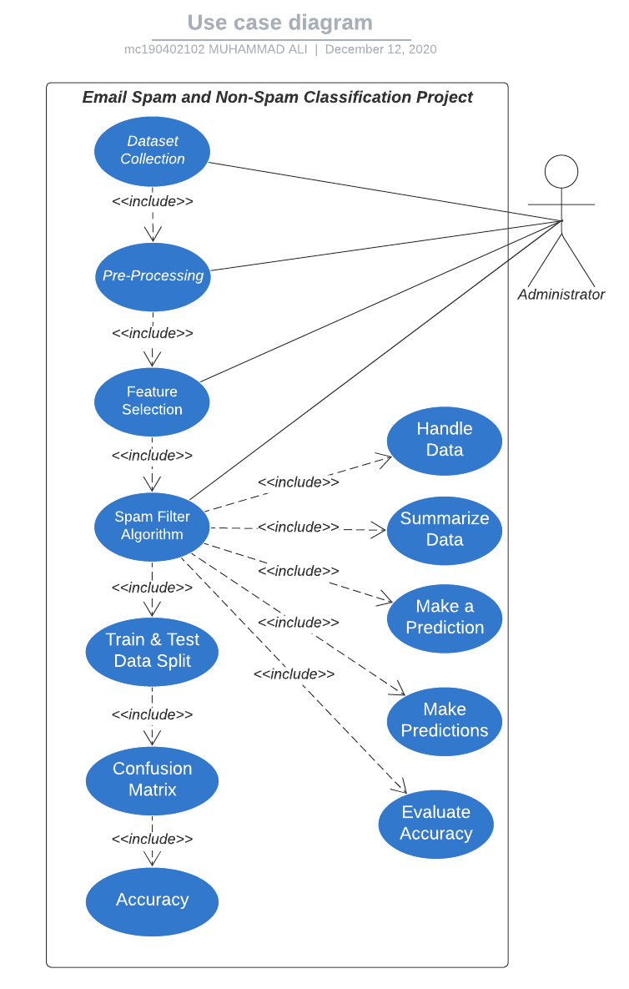

1.6.2 Usage Scenarios

Usage Scenarios 1:

USE CASE SCENARIO
Use Case Title | Data Collection
Use Case Id | UC-01
Action | Collecting Dataset
Description | This use case provides a dataset to the system which serves as a raw data input.
Alternative Paths | Instead of collecting an available dataset, one is made manually from the scratch.
Precondition | There must be a dataset available containing both spam and non-spam messages.
Post-Condition | The system will have the dataset as an unprocessed data.
Author/Actor | Administrator
Exception | Dataset is not available anywhere, in this case one will be created from the very scratch by collecting both spam and non-spam messages.

Usage Scenarios 2:

USE CASE SCENARIO
Use Case Title | Pre-processing
Use Case Id | UC-02
Action | Pre-processing the dataset.
Description | This use case pre-processes the dataset in order to transform the email message to be in form that is suitable for feature selection use case to have as an input.
Alternative Paths | Some pre-processing function of a python library gets deprecated so it will raise deprecation warning but will not affect the system flow.
Precondition | Dataset must be provided for pre-processing
Post-Condition | The system will have the email message in the pre-processed form, ready to be forwarded into feature extraction use case.
Author/Actor | Administrator
Exception | The machine on which the system will be deployed does not have python installed.

Usage Scenarios 3:

USE CASE SCENARIO
Use Case Title | Feature Selection
Use Case Id | UC-03
Action | Selecting relevant features from the pre-processed dataset.
Description | This use case extracts out the important features from the dataset to forward only those words to the spam filter algorithm that will contribute the most in the classification of spam and non-spam emails.
Alternative Paths | Some feature selection function of a python library gets deprecated so it will raise deprecation warning but won’t affect the system flow.
Precondition | Dataset must be of pre-processed form.
Post-Condition | The spam filter algorithm will be ready to have extracted features to be used in classifying spam and non-spam emails.
Author/Actor | Administrator
Exception | An email message containing only non-important words like articles which should logically lead to the removal of all the words

Usage Scenarios 4:

USE CASE SCENARIO
Use Case Title | Spam Filtering Algorithm
Use Case Id | UC-04
Action | Applying classification technique on the selected features.
Description | This use case classifies the dataset into spam or non-spam using selected features as input and text classification techniques.
Alternative Paths | Some function of a python-based machine learning library gets deprecated so it will raise deprecation warning but will not affect the system flow.
Precondition | The selected features must include words that convey meaning and should not include words that are meaningless like articles.
Post-Condition | The algorithm will provide a single result of whether the message is spam or non-spam.
Author/Actor | Administrator
Exception | The spam filtering algorithm fails identify the spam message and incorrectly classifies as non-spam (false positive).

Usage Scenarios 4.1:

USE CASE SCENARIO
Use Case Title | Handle Data
Use Case Id | UC-4.1
Action | Loading the dataset and split it into training and test datasets.
Description | This use caseloads the dataset into spam filter algorithm and splits it into training and test datasets.
Alternative Paths | If no pre-built library function will not be available for loading dataset then we will load it using self-written python code.
Precondition | The dataset must be available for loading the data into algorithm.
Post-Condition | The algorithm will have the dataset loaded into it.
Author/Actor | Administrator
Exception | The dataset fails to be loaded into the dataset.

Usage Scenarios 4.2:

USE CASE SCENARIO
Use Case Title | Summarize Data
Use Case Id | UC-4.2
Action | Summarizing Data
Description | This use case summarizes the properties in the training dataset so that we can calculate probabilities and make predictions.
Alternative Paths | Instead of using pre-built python function to get the summary of all the properties in the training dataset we write the code from the very scratch.
Precondition | The dataset must be loaded into algorithm.
Post-Condition | We will be able to calculate probabilities and make predictions
Author/Actor | Administrator
Exception | The dataset fails to be summarized.

Usage Scenarios 4.3:

USE CASE SCENARIO
Use Case Title | Make a Prediction
Use Case Id | UC-4.3
Action | Making a Prediction
Description | This use case uses the summaries of the training dataset to generate a single prediction.
Alternative Paths | Instead of using summaries we take the whole dataset features to make the prediction.
Precondition | The dataset must be in a summarized form.
Post-Condition | We will get a single prediction.
Author/Actor | Administrator
Exception | The algorithm fails to predict accurately based on summaries (the training loss is very high)

Usage Scenarios 4.4:

USE CASE SCENARIO
Use Case Title | Make Predictions
Use Case Id | UC-4.4
Action | Making Predictions
Description | Generating predictions given a test dataset and a summarized training dataset.
Alternative Paths | Instead of using summarized dataset we take the whole dataset features and divide them into two to make the predictions.
Precondition | The dataset must be available into two groups i.e. train and test datasets.
Post-Condition | We will get multiple prediction outputs
Author/Actor | Administrator
Exception | The algorithm fails to generalize the predictions.

Usage Scenarios 4.5:

USE CASE SCENARIO
Use Case Title | Evaluate Accuracy
Use Case Id | UC-4.5
Action | Evaluating Preconditions Accuracy
Description | Evaluate the accuracy of predictions made for a test dataset as the percentage correct out of all predictions made.
Alternative Paths | Instead of checking correct ones we check the percentage incorrect out of all predictions made.
Precondition | The algorithm must be generating predictions.
Post-Condition | We will get accuracy of predictions made for a test dataset as as the percentage correct out of all the predictions made.
Author/Actor | Administrator
Exception | The algorithm produces very low correct predictions rate i.e. high false positives and low true positives.

Usage Scenarios 5:

USE CASE SCENARIO
Use Case Title | Train & Test Data
Use Case Id | UC-05
Action | Splitting the dataset into train and test datasets.
Description | This use case splits data into 70% training & 30% testing data sets
Alternative Paths | The dataset is divided into 50% for train and 50% for test.
Precondition | The algorithm must be generating predictions with fair accuracy.
Post-Condition | We will get 70:30 ratio-based division of our dataset into train and test datasets, respectively.
Author/Actor | Administrator
Exception | The datapoints i.e. email messages in the dataset are in odd number therefore, dividing it into 70:30 will likely result in loss of some datapoints.

Usage Scenarios 6:

USE CASE SCENARIO
Use Case Title | Confusion Matrix
Use Case Id | UC-06
Action | Creating a Confusion Matrix
Description | This use case creates a confusion matrix table to describe the performance of a classification model.
Alternative Paths | We create confusion matrix with summarized training dataset-based predictions instead of testing dataset-based predictions.
Precondition | The dataset must be divided into two parts train and test dataset and we also have predictions.
Post-Condition | The Confusion Matrix will be created for further analysis.
Author/Actor | Administrator
Exception | The confusion matrix shows high value for false positives and low value for true positives.

1.7 Development Methodology

1.7.1 Chosen Methodology
- VU Model

I have studied both the Waterfall and Spiral methodologies and then I have decided to choose the VU Process Model for my project. University also guides me that you must use Virtual University Process Model for the project as it is a combination of both waterfall and spiral model, and it fulfills all the project requirements. Therefore, I chose VU Process Model. The detail of VU Process Model is as under:

- System Requirement Specification (SRS)
- Design Phase
- Test Phase 1
- Test Phase 2
- Development
- Final Report
- Presentation and Viva

Diagram of Project Model:
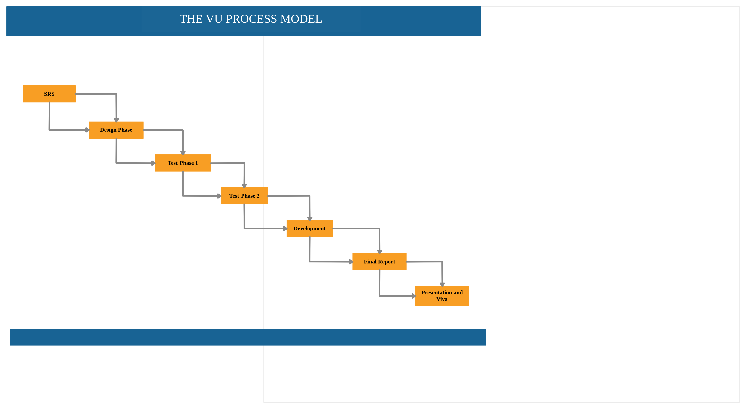

1.7.2 Reasons for Chosen Methodology
I choose VU Process Model for my project. Reasons of adopting this methodology is as under:

- Virtual University of Pakistan guides us that you must select VU Process Model for the project.

- Second reason is that only VU Model fulfills all the requirements of my project.

- Third, VU Process Model is the combination of Waterfall and Spiral Methodologies. One feature of waterfall methodology is the sequence of steps that we take in our methodology and one feature of spiral methodology is to go previous steps which is also included in our methodology.

1.7.2 Work Plan (Gantt Chart)

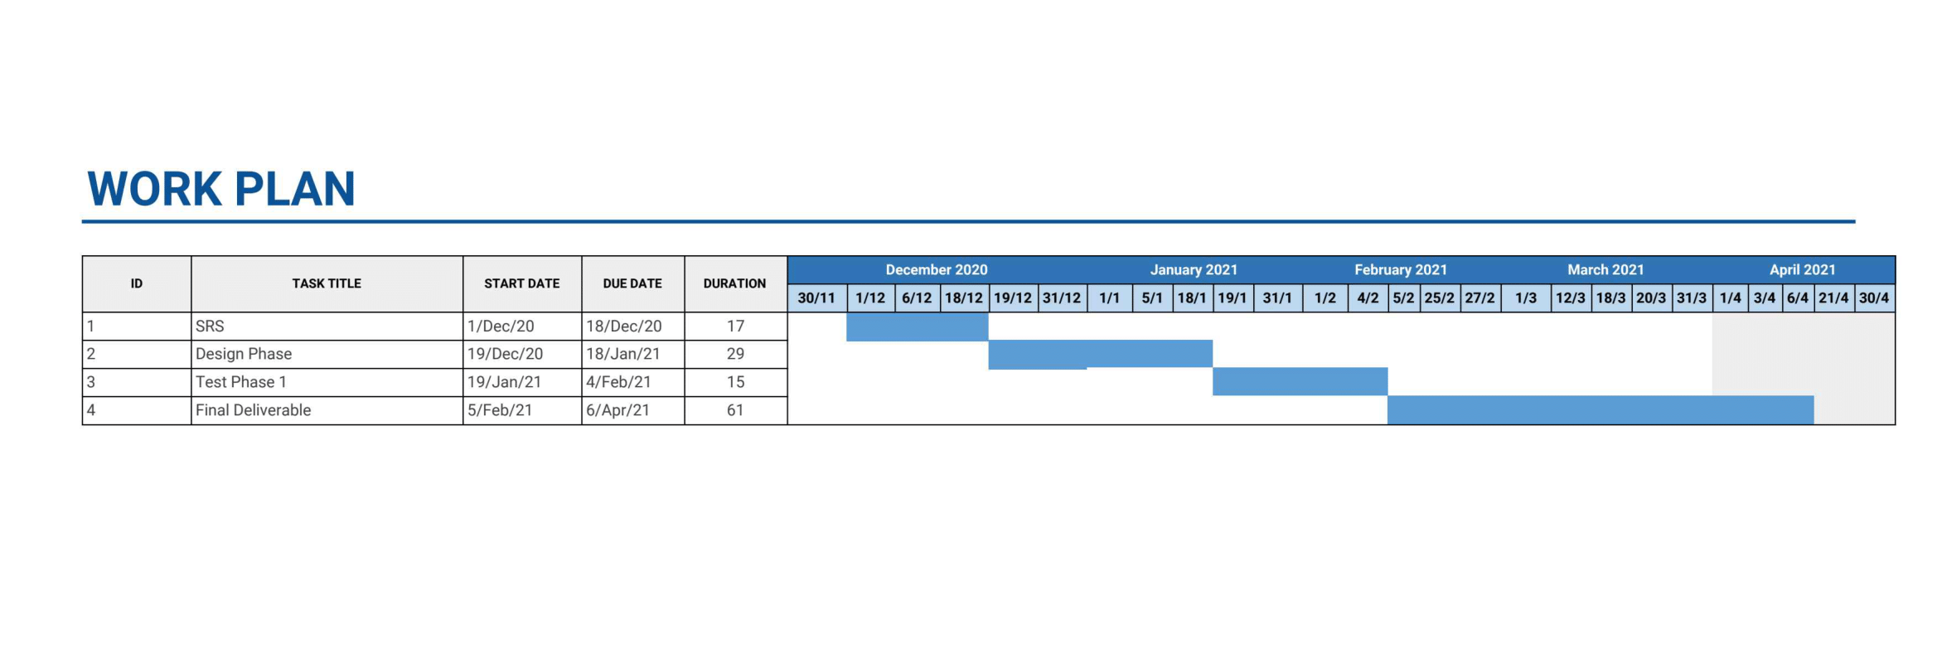

1.7.2 Project Schedule (Submission Calendar)

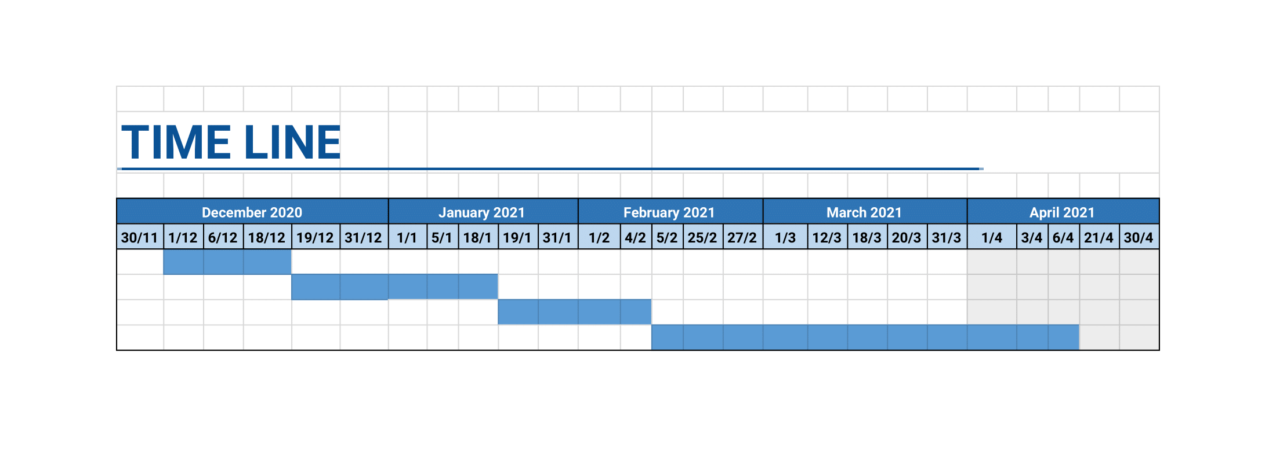

CHAPTER 2
Designing the Project

2.1 Introduction

Software design is a process by which the Email Spam and Non-Spam Classification application’s requirements are translated into a representation of its components, interfaces, and data necessary for the implementation phase. This chapter shows how the application will be structured to satisfy the requirements.

2.2 purpose

This chapter describes the architecture and system design of “Email Spam and Non-Spam Classification Project”, an AI based software agent that can be used to classify spam vs non-spam on email clients. This chapter will also illustrate the complete declaration for the development of system.

2.3 scope

This project needs a coordinated scope of work. These scopes will help to focus on this project. The scopes are:

- Using existing machine learning algorithm.

- Make use and classify of a data set including data preparation, classification, and visualization.

- Score of data to determine the accuracy of spam detection.

2.4 definitions, acronyms and abbreviations

ML | Machine Learning
SDLC | Software Development Life Cycle

2.5 Architectural Representation
(Architecture Diagram)

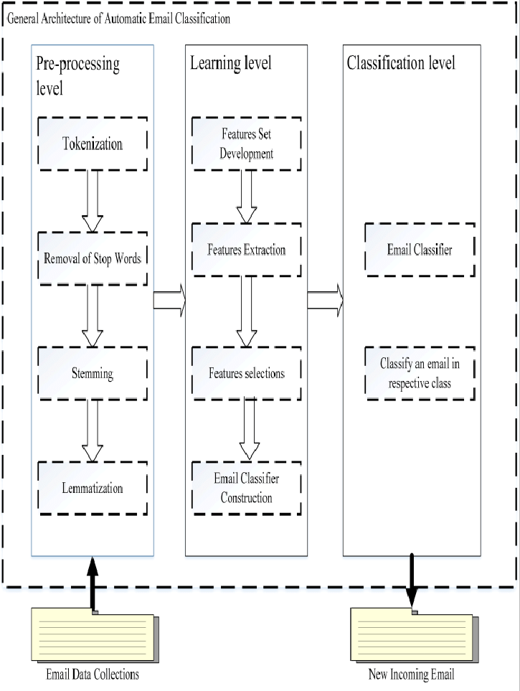

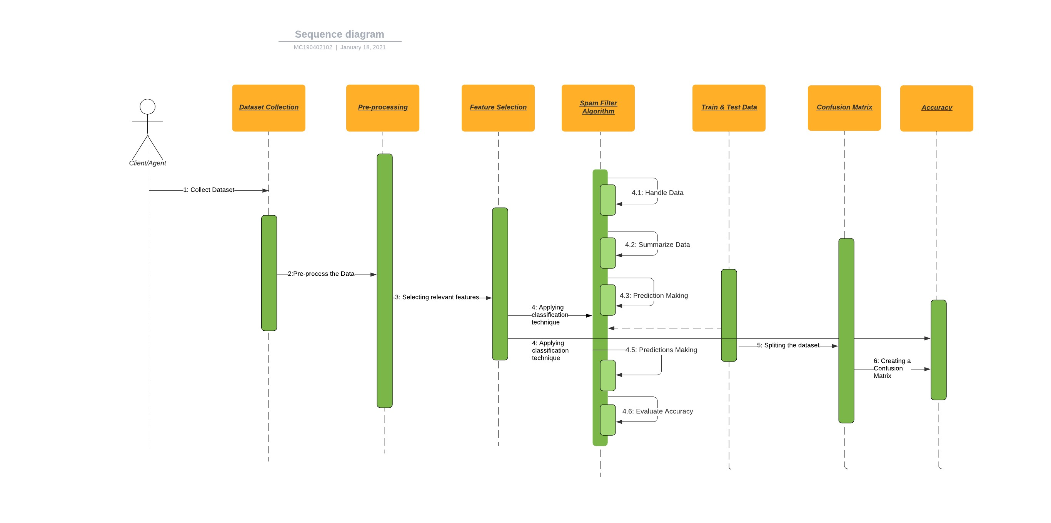
2.6 Dynamic Model: Sequence Diagrams

2.7 Object Model/Logical Model: Class Diagram

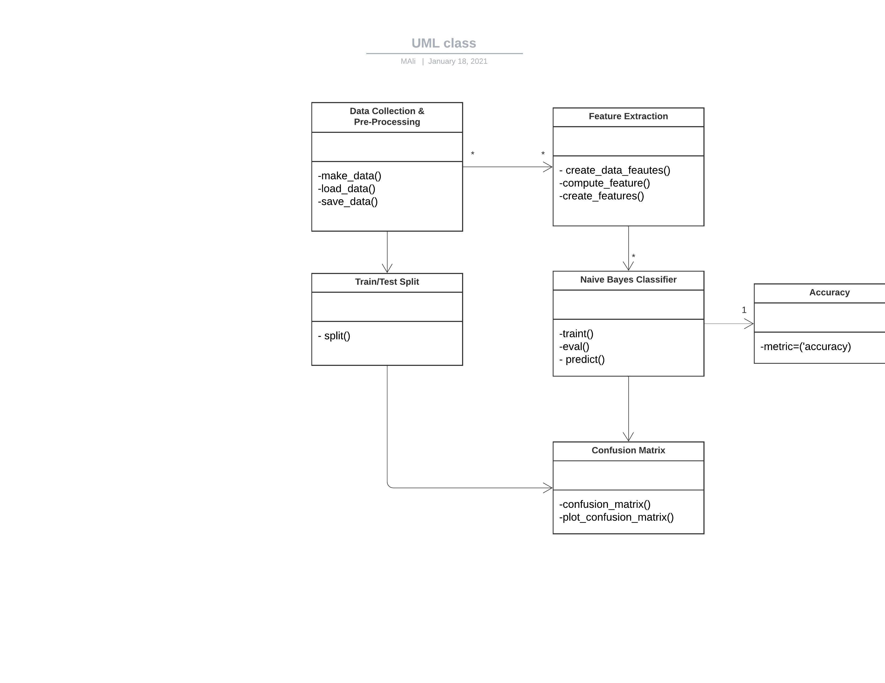

2.8 Database Model (Database Diagram)

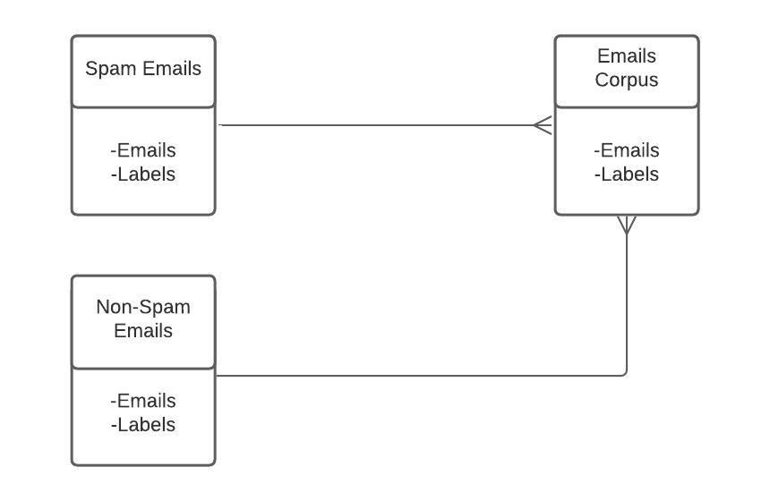

2.9 Graphical User Interfaces
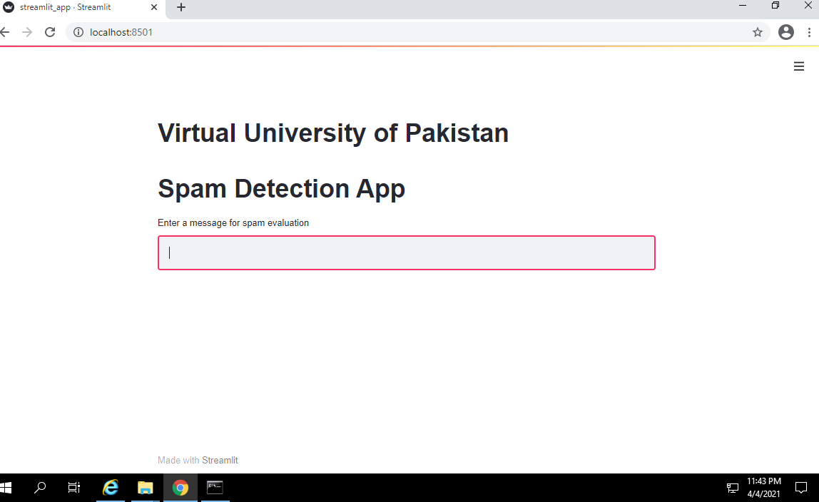
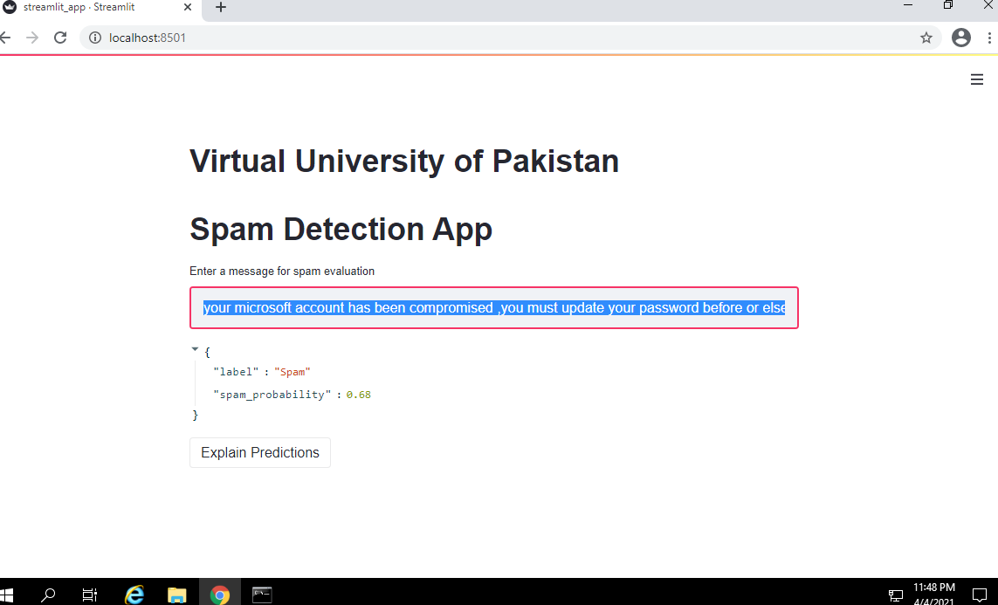
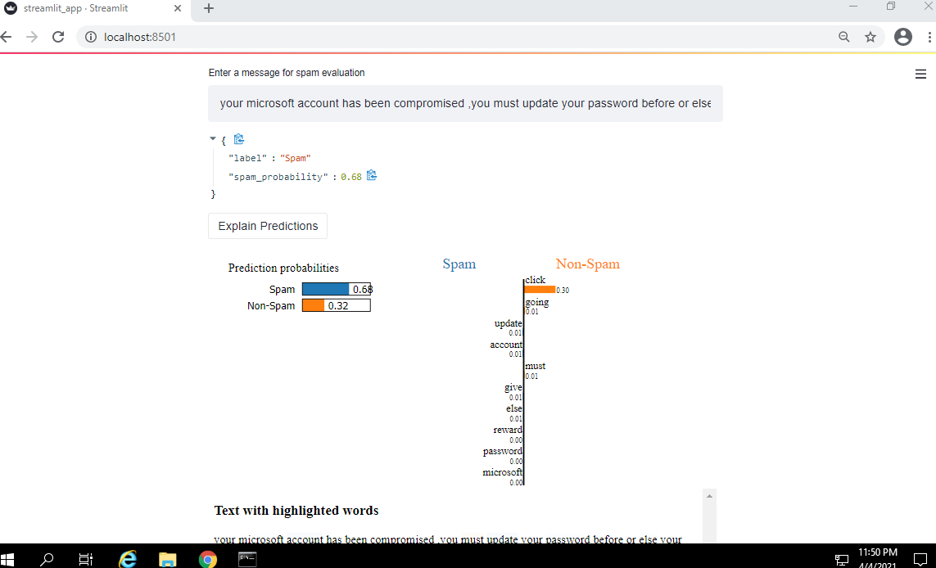
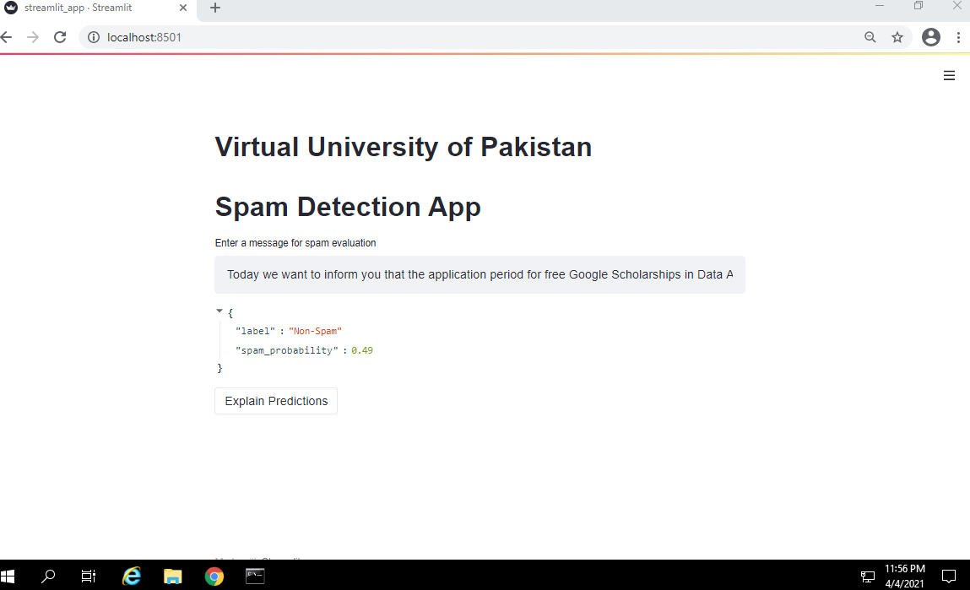

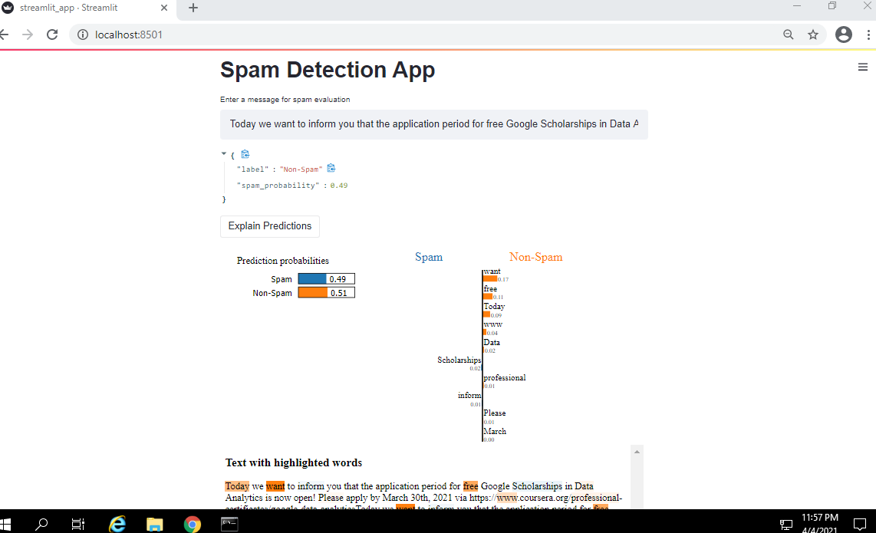

CHAPTER 3
Development

3.1 Development plan (Architecture Diagram)

REFERENCES

  - https://www.researchgate.net/publication/50235003_Supervised_Learning_Approach_for_Spam_Classification_Analysis_using_Data_Mining_Tools
  - http://bid.berkeley.edu/cs294-1-spring12/images/archive/6/6a/20120515031244!Spam-lupher-engle-xin.pdf
  - https://upcommons.upc.edu/bitstream/handle/2099.1/11321/J.Norte.pdf?sequence=1&isAllowed=y
  - https://www.researchgate.net/publication/287632678_COMPARISON_OF_MACHINE_LEARNING_TECHNIQUES_IN_SPAM_E-MAIL_CLASSIFICATION
  - https://www.hindawi.com/journals/acisc/2011/416308/
  - https://medium.com/@dtuk81/confusion-matrix-visualization-fc31e3f30fea
  - https://towardsdatascience.com/how-you-can-quickly-build-ml-web-apps-with-streamlit-62f423503305

APPENDIX

Chapter 1 | GATHERING & ANALYZING INFO
Chapter 2 | DESIGNING THE PROJECT
Chapter 3 | DEVELOPMENT

